|  |  |  |  |
| --- | --- | --- | --- |
| **Document Difficulty Level** | | | |
| **Beginner** | **Junior** | **Senior** | **Expert** |
| ■ | □ | □ | □ |

|  |  |
| --- | --- |
| **Topic** | Oracle SQL Language Fundamentals I |
| **Document Name** | SQL01-EX-01-05 |
|  |  |

# Oracle SQL Language Fundamentals I

## Exercise SQL01-EX-01:

**Definiton :** Write an SQL query that selects employee’s id, employee’s first name and employee’s department name for all employees. (Please use HR.EMPLOYEES and HR.DEPARTMENTS tables.)

**Sample Output :**

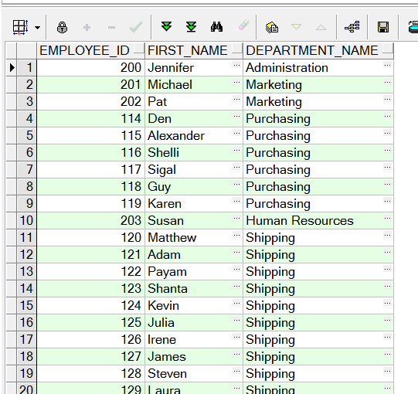

**Objectives** : To learn relations on tables and SQL language keyword JOIN.

**Exercise Keywords:** INNER JOIN, JOIN.

**Reply:**

select E.EMPLOYEE_ID,E.FIRST_NAME,D.DEPARTMENT_NAME from HR.EMPLOYEES E inner join HR.DEPARTMENTS D on D.DEPARTMENT_ID=E.DEPARTMENT_ID

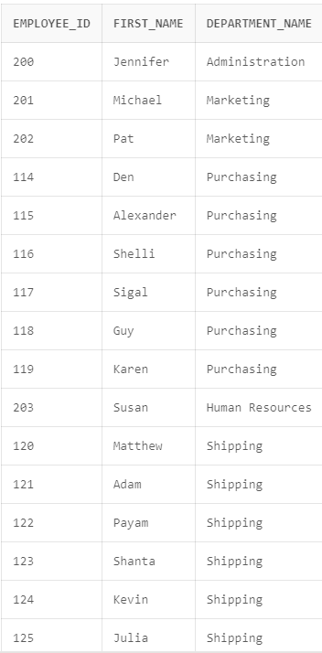 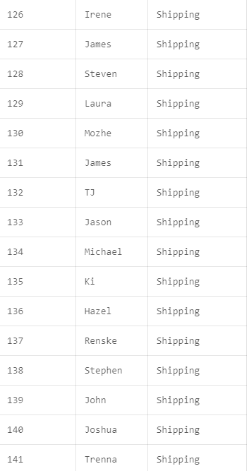

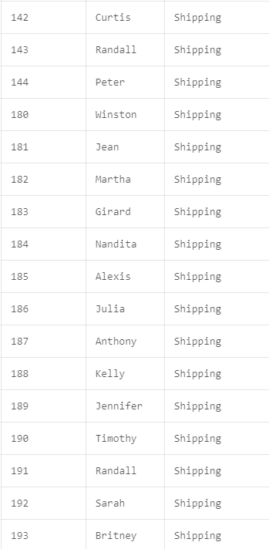

## Exercise SQL01-EX-02:

**Definiton :** Create a report that displays the employee’s id and their manager’s id. (Please use HR.EMPLOYEES table)

Tanım: Çalışanın kimliğini ve yöneticisinin kimliğini gösteren bir rapor oluşturun. (Lütfen HR.EMPLOYEES tablosunu kullanın)

**Sample Output :**

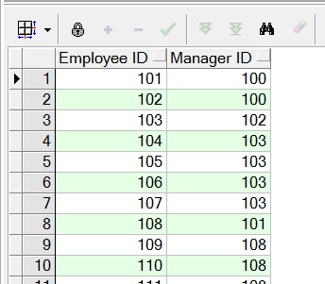

**Objectives** : To learn SQL join logic like SELF JOIN.

**Reply:** SELECT E1.EMPLOYEE_ID, E2.EMPLOYEE_ID AS MANAGER_ID FROM HR.EMPLOYEES E1 LEFT JOIN HR.EMPLOYEES E2 ON E1.MANAGER_ID = E2.EMPLOYEE_ID;

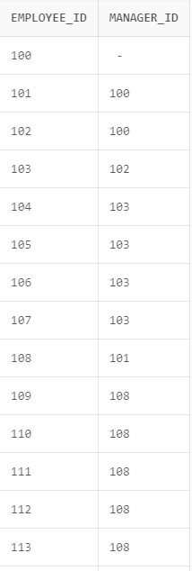 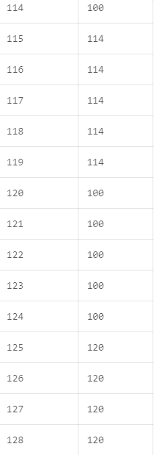

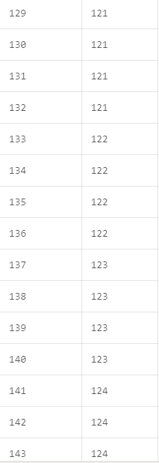 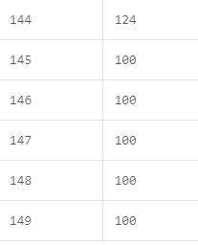

Exercise SQL01-EX-03:

**Definiton :** For example; first three character of PHONE_NUMBER column gives us a operator of employee. Create a report that displays the operators and their total subscriber. (Please use HR.EMPLOYEES table)

Tanımı : Örneğin; PHONE_NUMBER sütununun ilk üç karakteri bize çalışanın operatörünü verir. Operatörleri ve toplam abone sayısını gösteren bir rapor oluşturun. (Lütfen HR.EMPLOYEES tablosunu kullanın)

**Sample Output :**

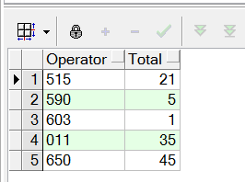

**Objectives** : To learn basic SQL keywords like COUNT, SUM, CASE.

**Reply:** select COUNT (Operetor) from employees and

select SUM (Total) from employees

## Exercise SQL01-EX-04:

**Definiton :** Write a query that displays the grade of all employees based on the value of the column JOB_ID, using the following data: (Write two version with CASE WHEN and DECODE)

Tanım: Aşağıdaki verileri kullanarak JOB_ID sütununun değerine göre tüm çalışanların notunu görüntüleyen bir sorgu yazın: (CASE WHEN ve DECODE ile iki versiyon yazın)

|  |  |
| --- | --- |
| **Job** | **Grade** |
| AD_PRES | A |
| ST_MAN | B |
| IT_PROG | C |
| SA_REP | D |
| ST_CLERK | E |
| None of the above | 0 |

**Reply: SELECT JOB_ID, DECODE (JOB_ID, 'ST_CLERK','E', 'SA_REP','D', 'IT_PROG','C', 'ST_MAN','B', 'AD_PRES','A', '0')GRADE FROM HR.EMPLOYEES;**

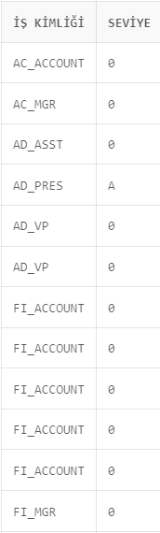 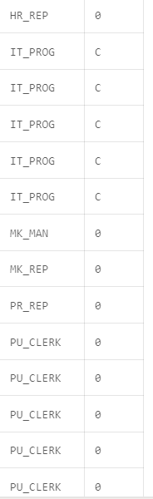 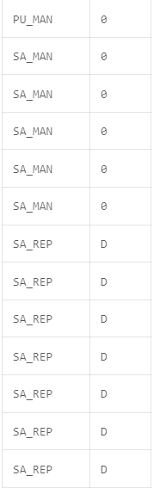

|  |  |
| --- | --- |
|  |  |

## Exercise SQL01-EX-05:

**Definiton :**

Select employees’ first name and last name as masked with “*” character as shown in sample output below.

Aşağıdaki örnek çıktıda gösterildiği gibi çalışanların adını ve soyadını “*” karakteriyle maskelenmiş olarak seçin.

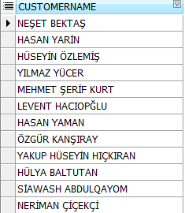

**Sample Output :**

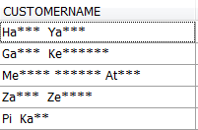

**Objectives** : To learn basic SQL functions like length, substr, instr, trim, initcap, rpad, lpad, regexp_replace, regexp_substr

**Reply:**